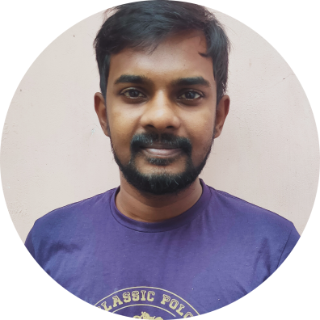  Hello! I’m Darwin  241E1,PSG Garden  Aiyothyapatnam  salem  +91 8870711600  avdarwin@iamadesigner.in  www.iamadesigner.in  ABOUT ME  I’m a creative and technically competent graphic/web designer with 4 years of post-qualification experience  in creating info-graphics, Facebook ad creatives, banners ads, websites and more .Passionate about work in a product based company, as that involves creating graphics in all short of fields.  QUALIFICATIONS  2010-2014  B.E(CSE)  Sona Tech (salem,TN)  2016  Graphic Design course  Aspire Gate (j.p nagar,Bangalore)  2020  After effects cc 2020  (udemy) |  |  |  | SKILLS  Illustrator – Advanced  Photoshop – Advanced  Wordpress – Advanced  After Effects – Intermediate  Html/Css – Advanced  PHP/Mysql– Intermediate  EXPERIENCE  2018(jan) – 2022(feb)  Web Developer/Graphic Designer/product analyst  Smz Brandlines  I was responsible for Making WordPress e-commerce websites, vector graphics using illustrator, Creating motion graphics videos and Product analyzing / photo shoots for amazon sales.  2017(may-dec)  Front-end Ninja  Searchpointer media solutions (PVT LTD)  I work with clients, briefing and advising them on design style, format & process. I prepare rough drafts of material based on an agreed brief, developing concepts, graphics and layouts for product illustrations, logos and websites.  PORTFOLIO  https://www.iamadesigner.in – please see my website for more.  Let’s work together!

